**EXPERIMENT 4: CREATING A STATIC**

**WEBSITE ON AMAZON S3-USING AWS SYSTEM MANAGER**

**AIM:** To create a static website on Amazon S3 using AWS system manager.

* Sign in to the AWS Management Console and click on Amazon S3 Console.
* Click on create a bucket.
* Enter the name of the bucket and the region you want to create it in.
* Accept the default settings and then click on create a bucket.

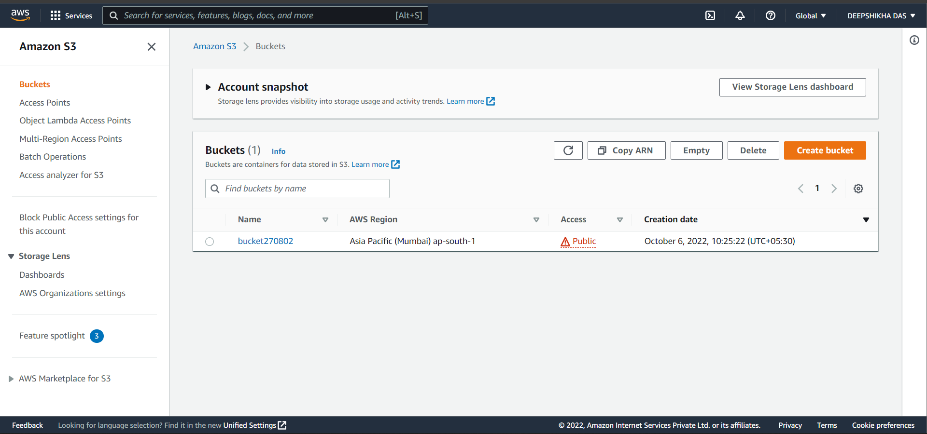

* In the buckets list, click on the bucket you just created and choose properties, then under static website hosting click the enable option.
* Then click on the upload option after selecting your bucket and upload your project
* files(index.html,style.css,main.js). Also, make sure that the project files you will upload have proper names as they are case-sensitive.

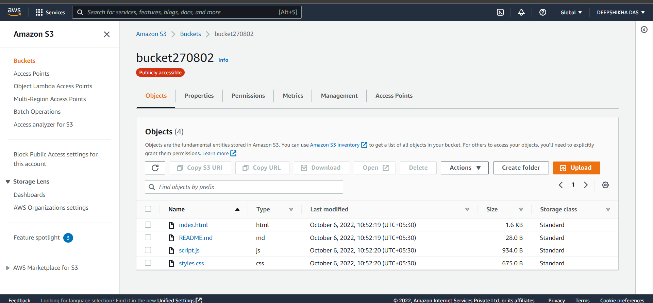

* After configuring the website you can use the endpoint to test the website out.
* choose the name of the bucket you just configured and then choose permissions under that block public access will be visible, click on the edit option and save the changes.
* under the bucket permissions there will be a bucket policy, click on that and paste this

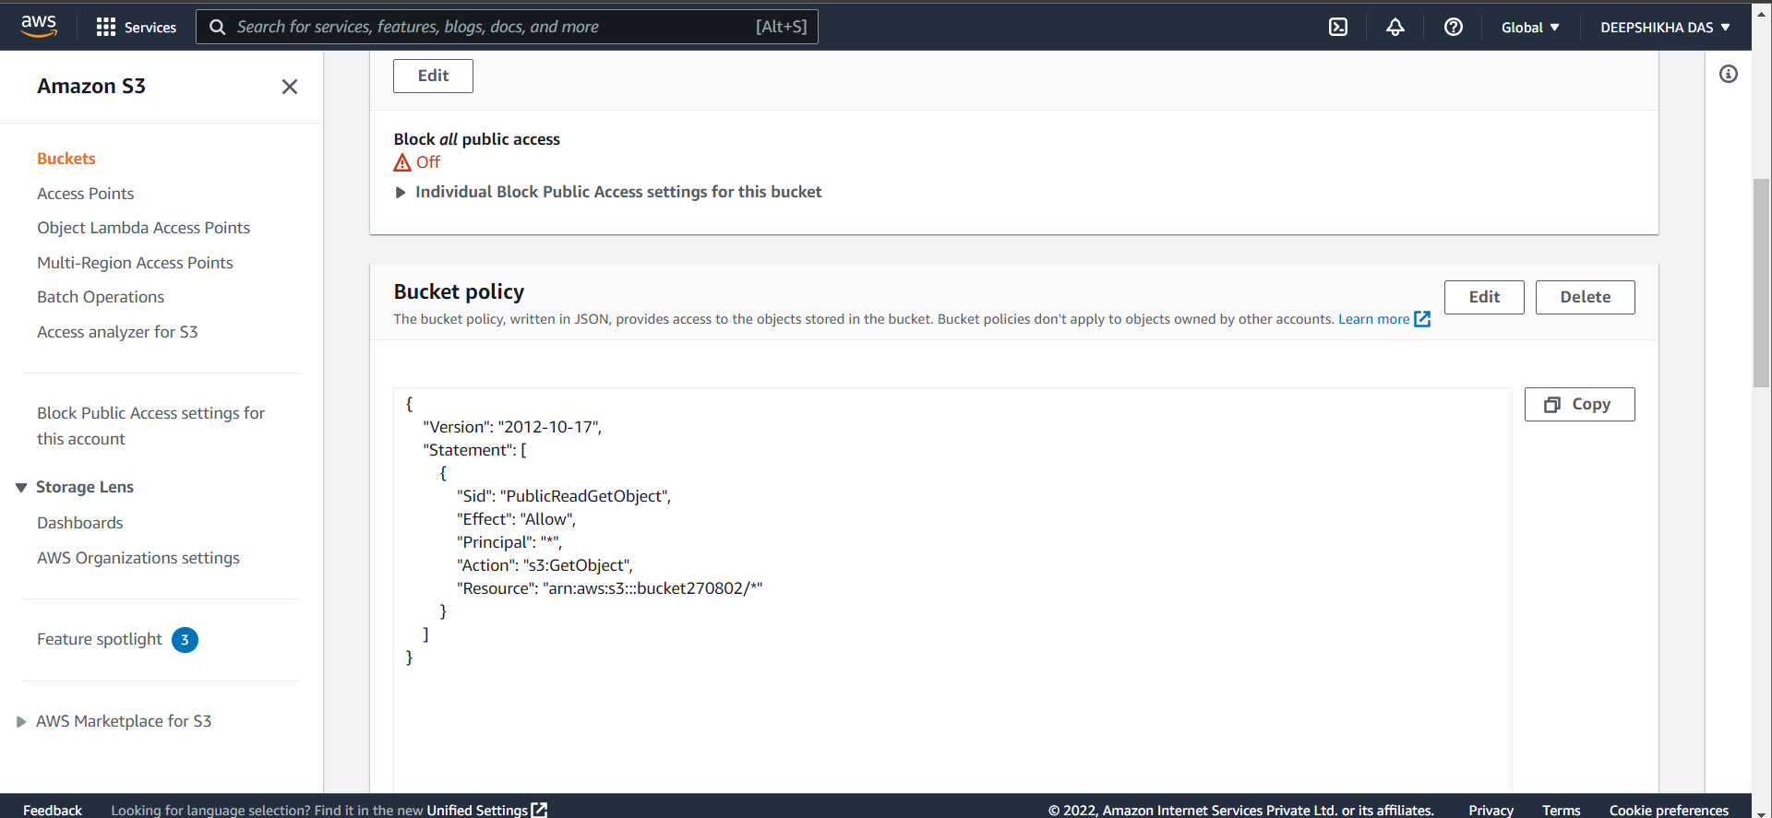

* Under the buckets, choose the name of your bucket which you just created, and in the properties, choose a static website hosting - then choose your bucket endpoint
* Now you can access your website as it has successfully been hosted.

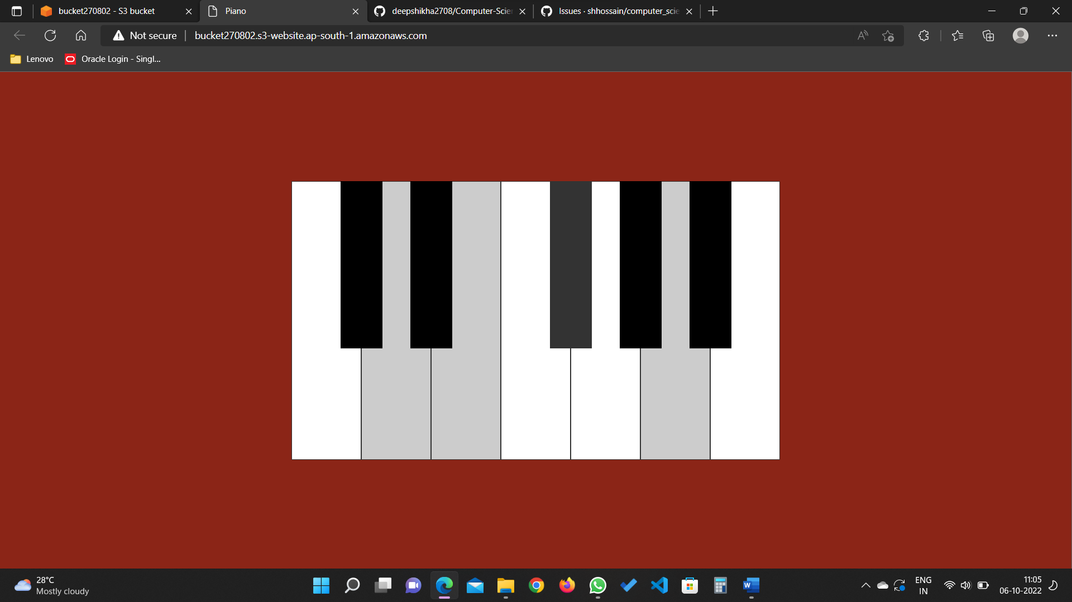

**RESULT:**

A static website has been successfully created on Amazon S3 using AWS System Manager.